Output Of Automate A Web Application

1.When we our program to check test case and also chech user input

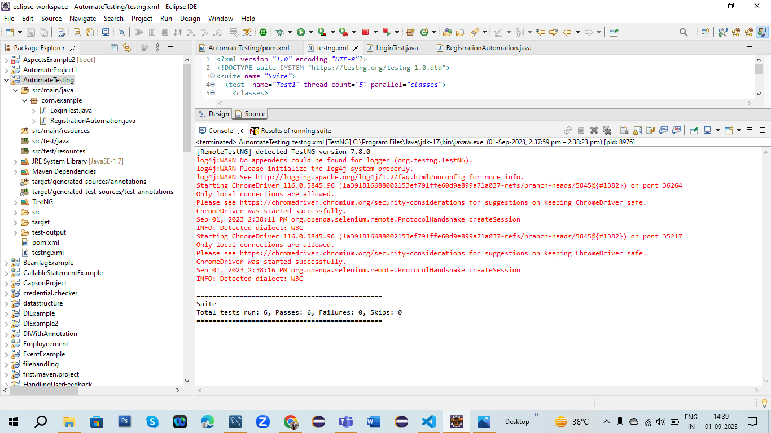

2.When we check user input and excepted output is

